|  |  |  |  |
| --- | --- | --- | --- |
| **Tech** **Mahindra**  Scotia Release and Deployment Process      **Presented By:**  aNAMIKA . ,  dANIEL aLBERTO TORRES VELASCO,  HUMBERTO RAMÍREZ ANTONIO  **Presented For**: rAMA VARMA RAJA  **State**: Draft    Versión 1.0 |  |  |  |

Contents

Scope of Document: 3

Current Processes: 4

Developer Task 5

Software Requirements: 5

Application Information 5

Local Environment 5

Code Control Task 22

Operation Team Task 28

Operation Team Notification 28

Get Deployable Version 29

Deploy Artifact 31

SEL Servers Information 36

# Scope of Document:

This document explain us about the current deployment process which Scotia bank is following for SEL Project.

# Current Processes:

The current process to deploy a new version of SEL application contains the following steps:

* Developer Task
* Code Control Task
* Operation Team Task

We are going to describe each phase in detail to have a better understanding about the process that Scotiabank Mexico is following to promote the new versions SEL application.

# Developer Task

## Software Requirements:

* MyEclipse 9.0
* Java version integrated with WAS 7

## Application Information

SEL Application is composed by **IE, GSMS** and **Ticket** projects, this projects content the code and should be compiled. Each one of this projects should be exported as **.ear** file

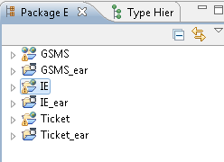

## Local Environment

To create a developer workspace, we need to follow this instructions as a Developer.

* Download from SERENA Dimensions (a SCM Tool) the version of code to compile

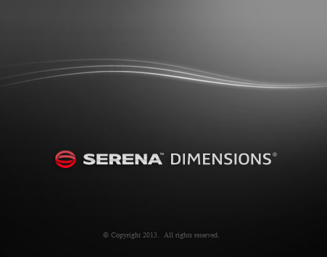

* For that, you have to access to Serena dimensions with your Scotia ID.

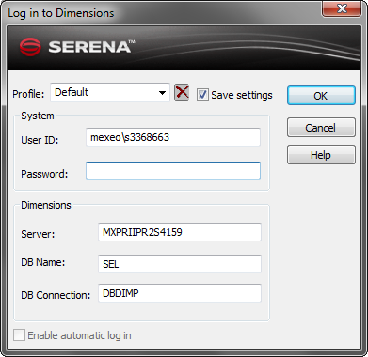

* Select the option Project\Open Project.

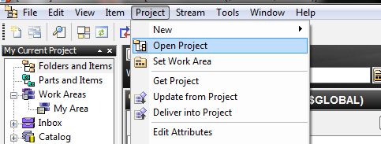

* In the displays windows This Project, after that, select in Product: SEL, in Project: SEL, after click Open.

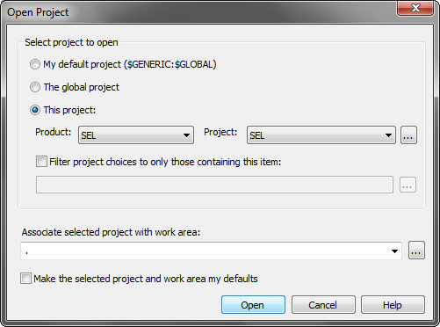

* After the open project, displays the next window.

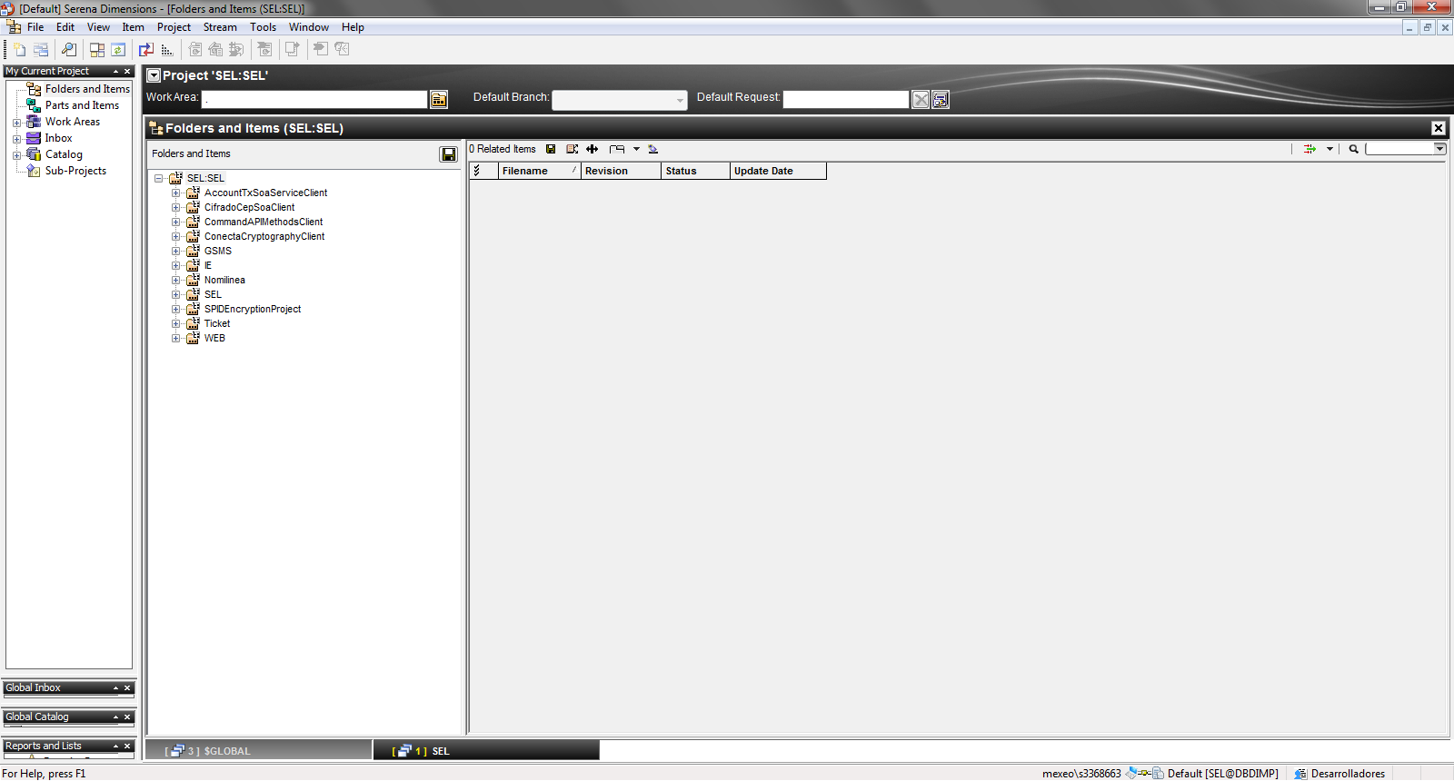

* Then, select in left menu Catalog-Baseline.

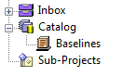

* Then, displays the next window.

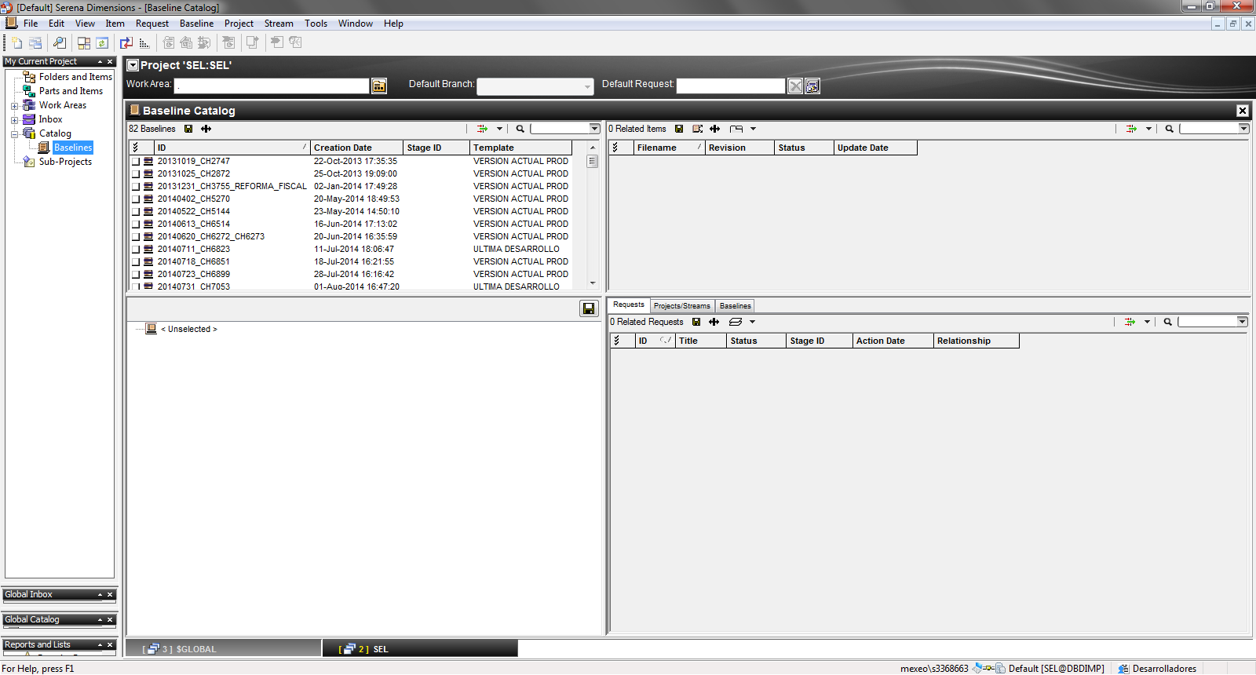

* In WorkArea select the path to download the code for that version.

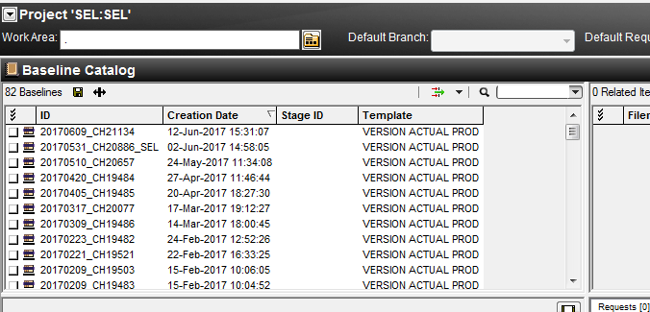

* When displays the next window, select the path to check out the source code and select Ok.

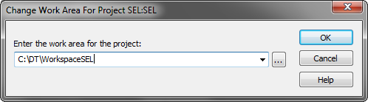

* Confirm the path selected.

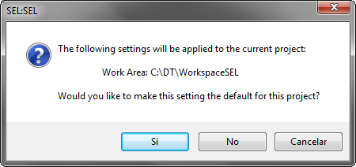

* Then, in Baseline Catalog section, order by Creation Date, select the first row, with mouse secondary button, select the option Get(Recursive).

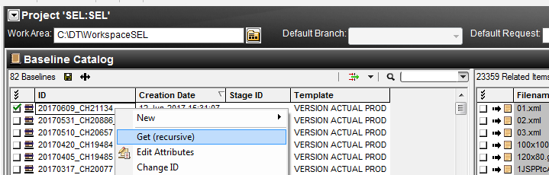

* Select the path to check out the source code, and click Aceptar.

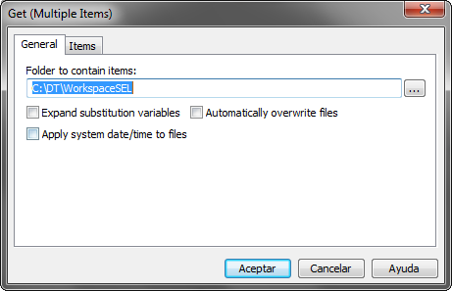

* Wait to finish check out.

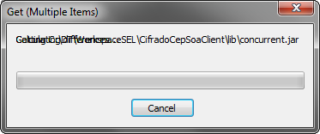

* Open MyEclipse and select the corresponding workspace.

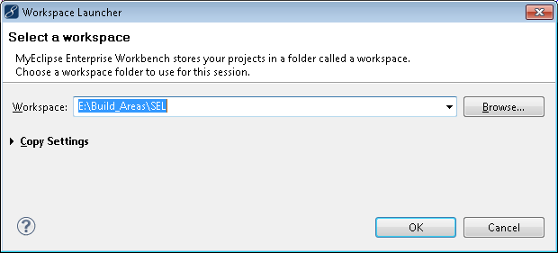

* Validate that the Build Automatically option in the Project menu is disabled.

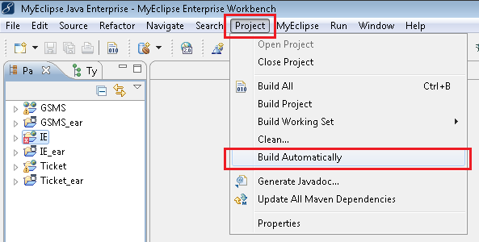

* Validate that each project has the Java library as WAS 7. To do this, right click on the project and select the option Build Path \ Configure Build Path.

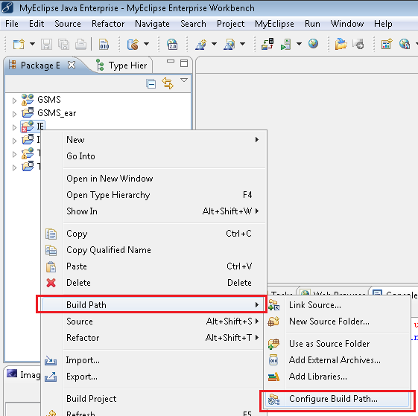

* In the Libraries tab, validate the java version

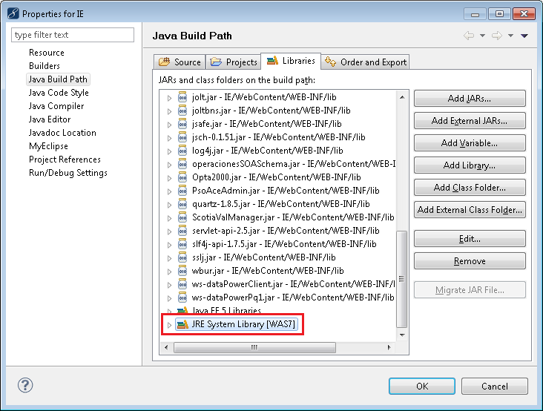

* In this step we have two options:
  1. If the version is correct in each projects, continue with the next step
  2. If the version is NOT correct, select the library and click Edit. In the window shown, in the Alternate JRE option select WAS 7

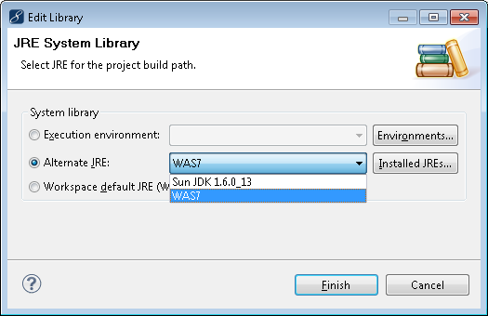

* 1. If the WAS7 version is NOT installed, you should install. For that, click Installed JREs and in the windows that displays, select Add button.

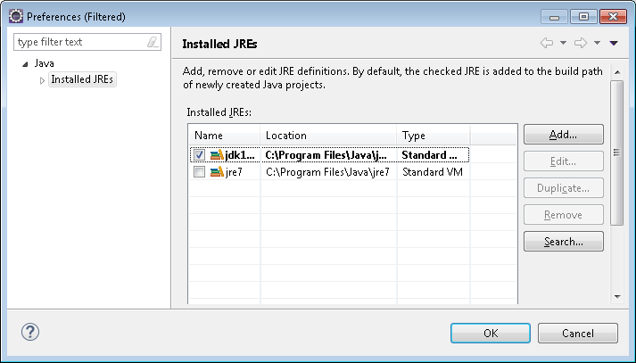

* 1. Select Standard VM

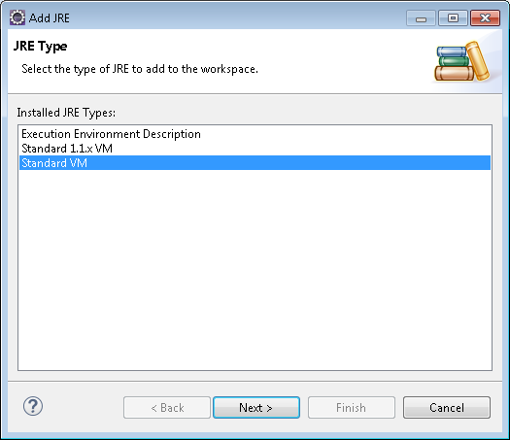

* 1. Select Directory

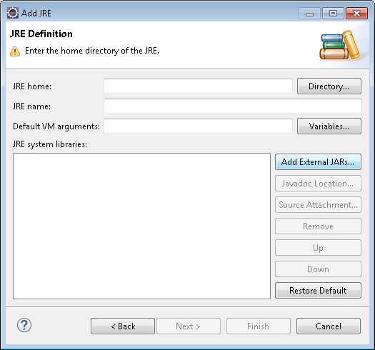

* 1. Select the folder where the required java version is installed, usually it is in "C:\Program Files\IBM\WebSphere\AppServer\java" and click Aceptar

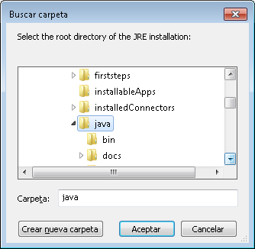

* 1. Then, click Finish

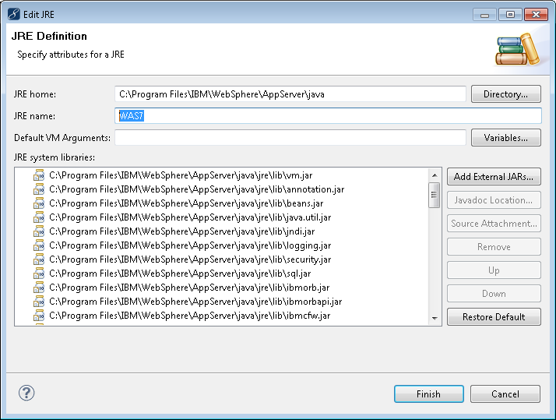

* 1. Now, the library should be enabled.

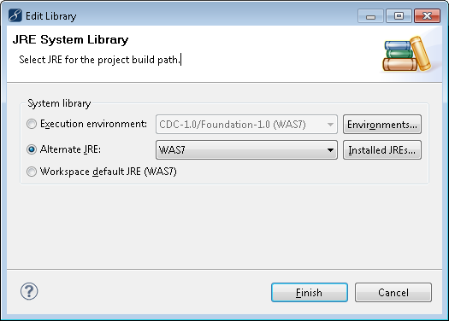

* 1. Select the Library and click Ok.

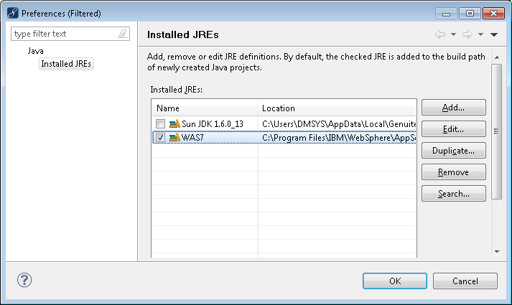

* Select the projects to compile with right click select Refresh or press F5 to update.

**NOTE**: This activity must be performed each time you update code in the workspace

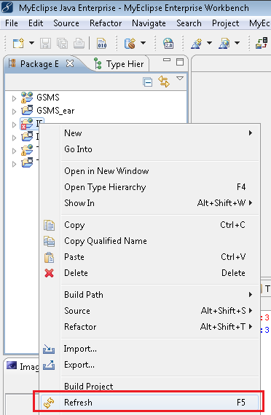

* Wait finish Refresh process

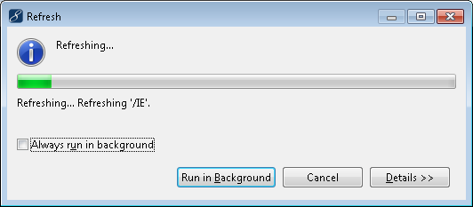

* Select the Project\Clean menu.

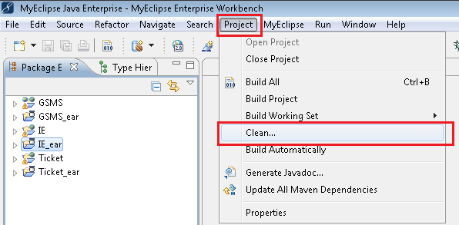

* Select the "Clean projects selected below" option and the project(s) you wish to compile. Also select the option "Start build immediately" and the option "Build only the selected projects"

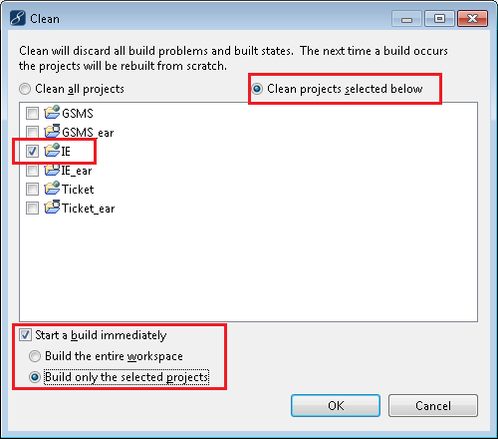

* Wait to finish Compilation Projects process

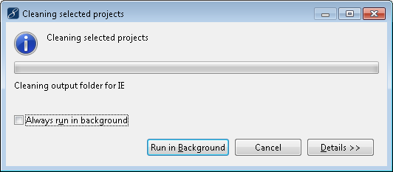

* In case there are Java type errors in the Problems section, it must be notified that Development must be notified for review and correction.

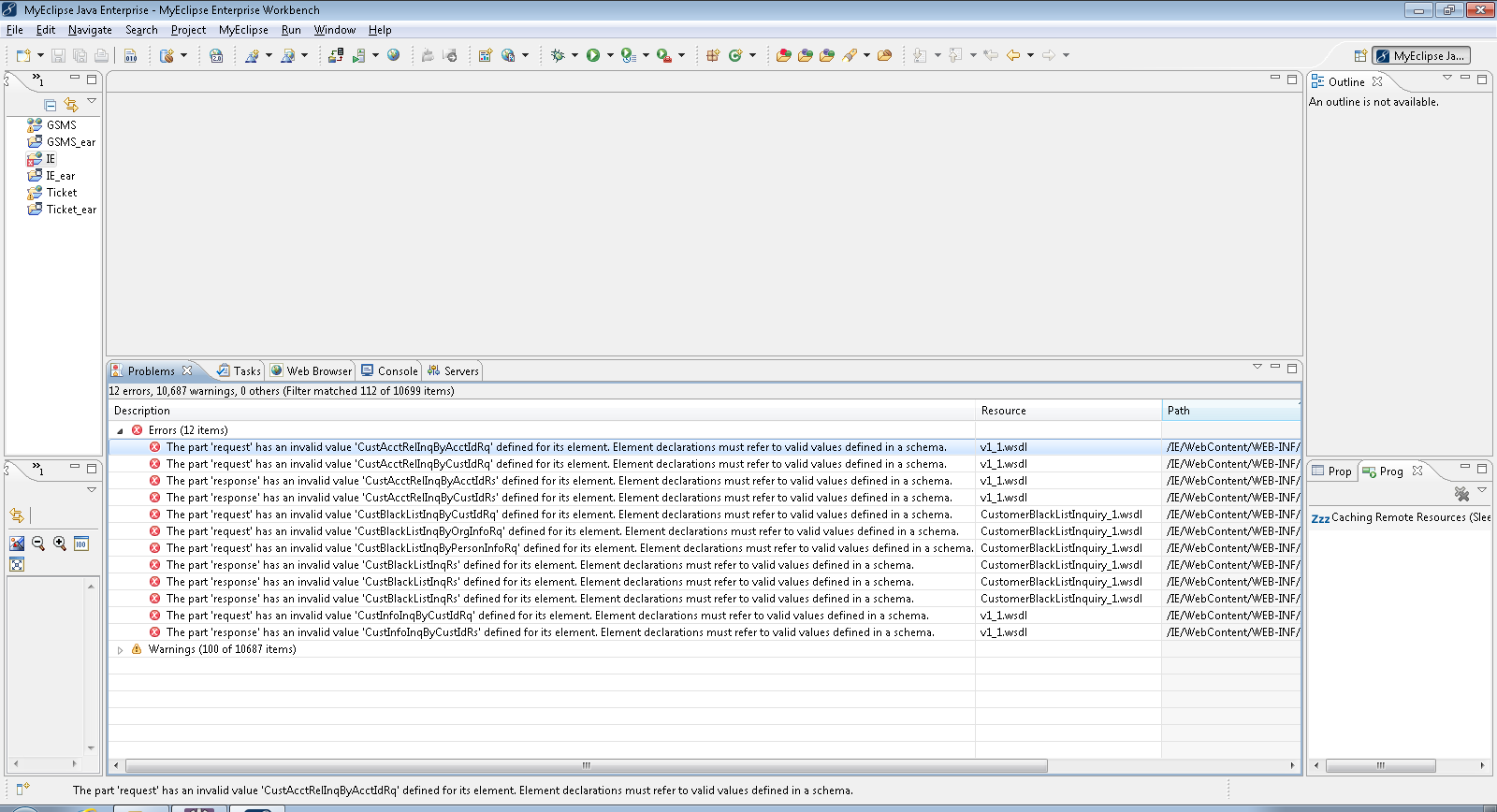

* If the Problems section does not show any errors, it means that the compilation was successful.

**NOTE**: Warnings can be ignored.

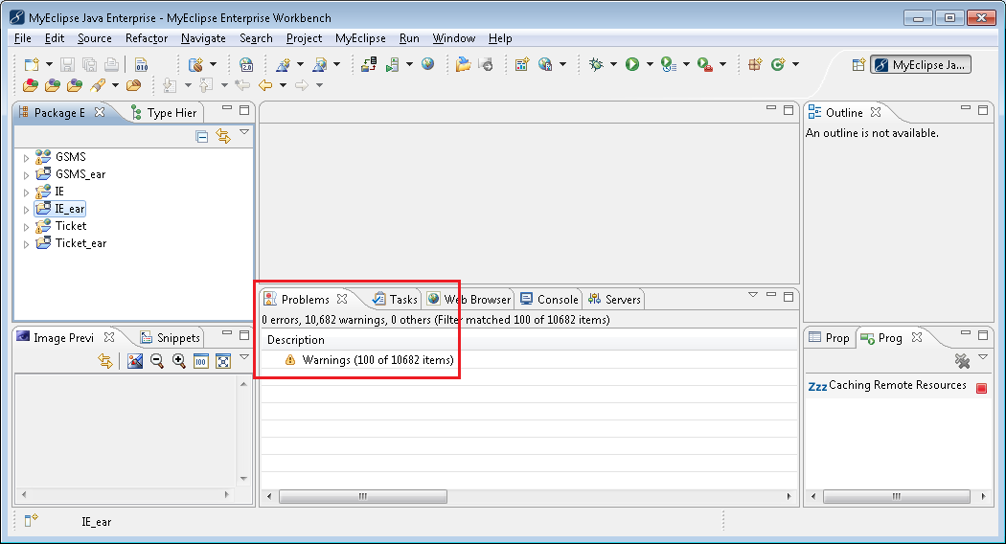

* Generate EAR Artifact, for that, go to menu File\Export

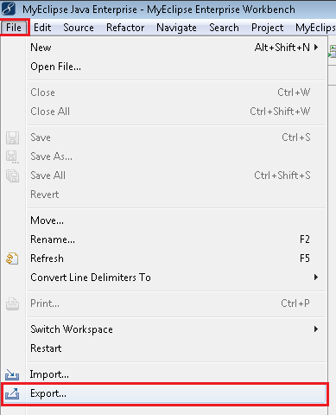

* Select the option Java EE\EAR file.

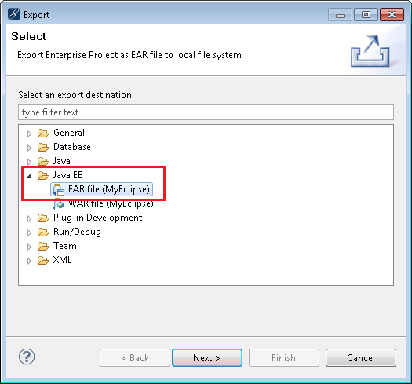

**NOTE**: In case that displays the next window, click in Close and continue.

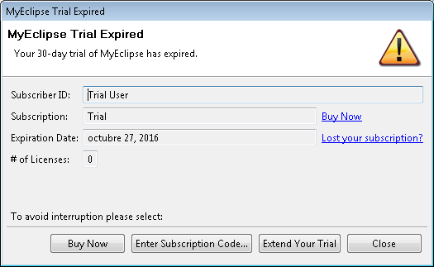

* Select the project to export and click Browse.

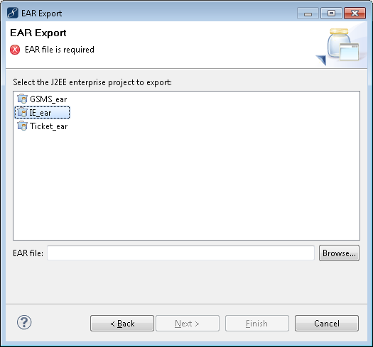

* Select the path where will be exported the EAR, in this case should be **E:\Build_Areas\SEL\EARS**.

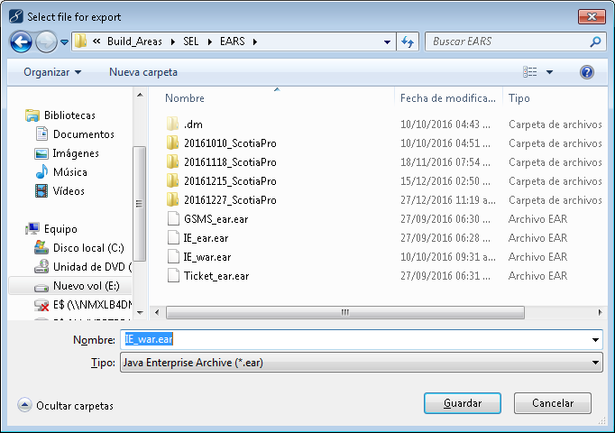

* Click Finish.

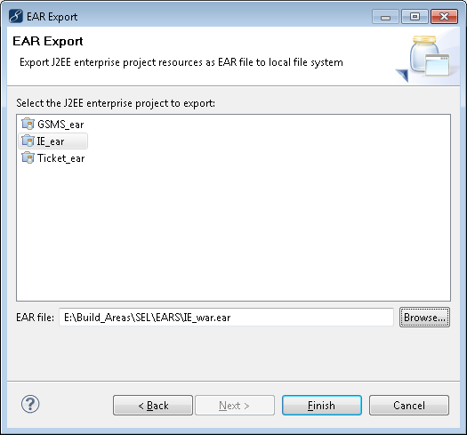

* Confirm the overwrite file.

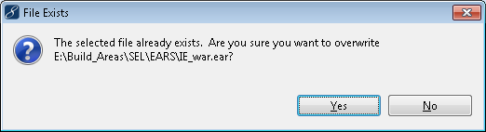

* At the end, the EAR file should be generate

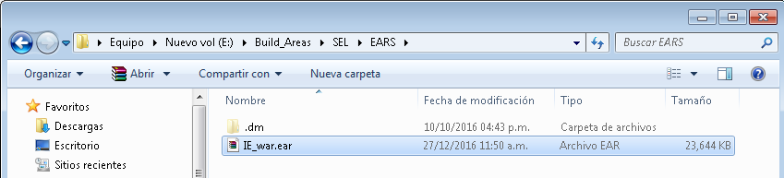

* Send email notification to ask for permission to promote the new changes.

# Code Control Task

The Source Code Control Team will receive an email notifying for promotion of the code.

Email will contain the following information as example:

|  |
| --- |
| **Requirement id** CHR01 - Change Date Format Web Page  **Buil Versión** 21/06/2017  **New Config Files** (Shared by mail or shared folder)  **New Code Files** (Shared by mail or shared folder)  **Next Environment** DEV/TEST/PROD |

For Dev environment, email will be send directly to source code control team. However for UAT and Prod, Release manager approval is required. Release Manager will provide his approval and send the email to source code control team to continue release to next environment.

Source code control team will receive the email and start the release process in respective environment.

Source code control team will take the specific file either by email or shared folder as seen in below snap:

|  |
| --- |
| IPADMIN=172.19.137.44  PUERTOADMIN=80  IPAUT=1172.19.137.XX  PUERTOAUT=81  WSDL=/sbwsAdmin/commandAPIMethodsService/CommandAPIMethodsService.wsdl  WSDLAUTH=/sbwsAuth/commandAPIMethodsService |

Artifacts are picked from the Serena Dimensions.

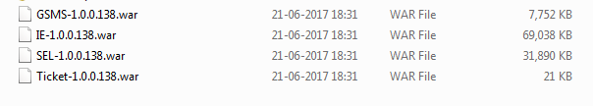

Source code control team will open the package and make respective changes to config files.

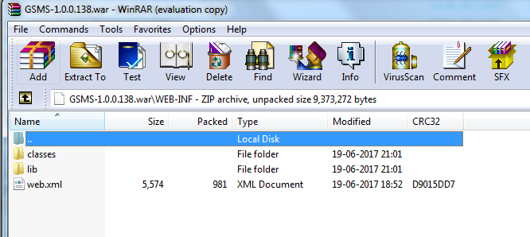

Add/Replace the files in the config file based on the environment to be deployed. As in below snap it is having connection details.

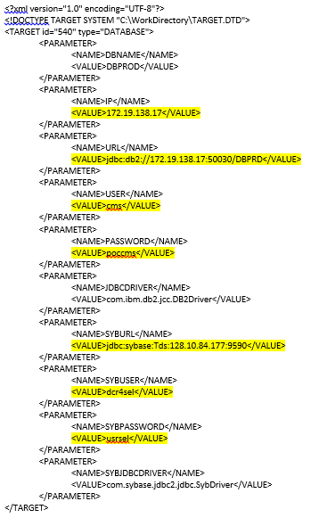

We have the web.xml file. It contains the connection with database and username and password.

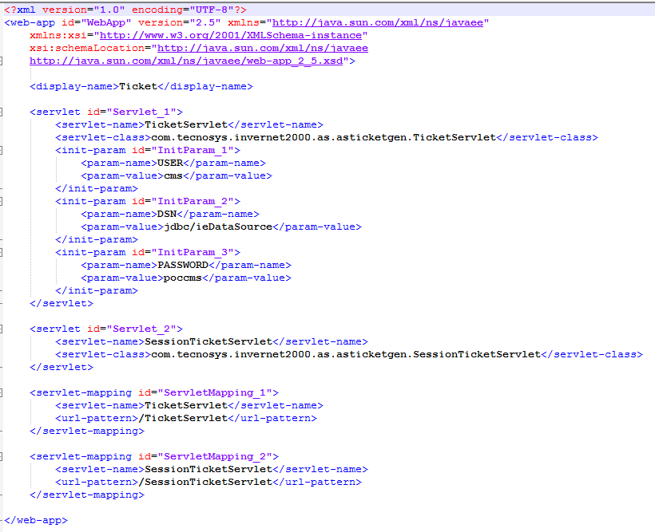

The below snap shows the cluster information

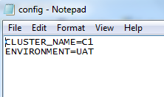

Below snap is also specifying all the details of the different environment.

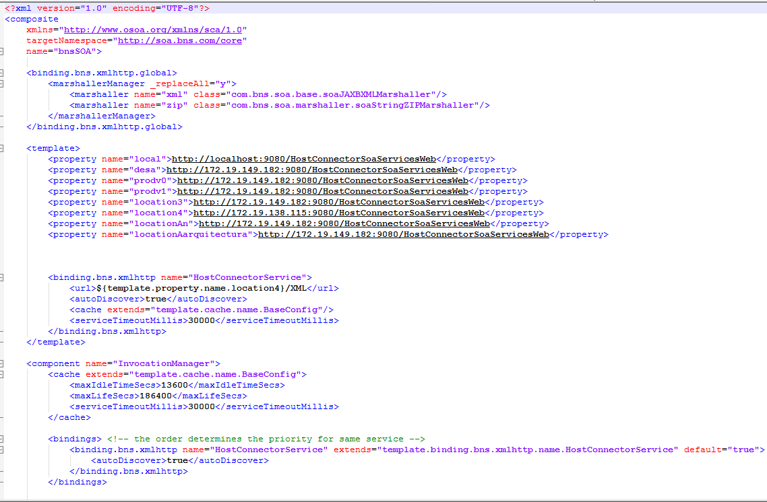

Source code control team will make the changes to the configuration files and close the package as shown in below snap:

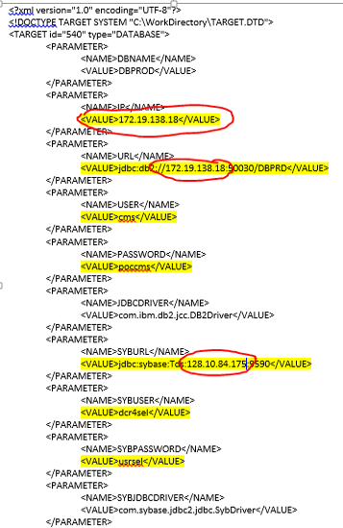

Now package again with new war files with new version number(1.0.0.139).

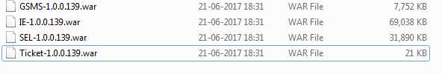

Upload the new package to the Serena Dimension.

An email will be triggered to the operation team with Package location in the Serena Dimension.

At last the Operation team will deploy the package to that environment.

**Please note**: The process is completely manual. Currently they are not having any error/failure handling mechanism with them.

# Operation Team Task

The last part of the process to promote a new version of the SEL component in the correct environment ends whit the following steps.

## Operation Team Notification

The department that is in charge of these kind of activities is Scotiabank Operation Team.

The Operation Team department receives a mail notification to promote one artifact to a specific environment.

|  |  |
| --- | --- |
| Mail Information |  |
| Requirement id | CHR01 - Change Date Format Web Page |
| Build Version | 21/06/2017 |
| New Code Files | Shared by mail or shared folder location by Scrum Cell |
| Next Environment | DEV/TEST/PROD |
| Scheduler | Only if the Deployment need to be done in a specific hour ( for example, and the end of the customer operation) |

This mail need to contain all the approvals for the specific environment, having the following behavior:

|  |  |
| --- | --- |
| Definition of Approvals |  |
| DEV Environment | Is not required because the owner of the environment is Scrum Cell |
| QA Environment | Approval for Information Security, Scrum Cell |
| PROD Environment | Functional and Non Functional Test Cases in QA are SUCCES  Approval for Information of Security, Code Control and Directors of the corresponding departments |

If the mail notification has all the approvals the operation team can continue with the deployment tasks.

## Get Deployable Version

As an Operator you need to follow the next steps to get the latest version of the artifacts.

* For that, you have to access to Serena dimensions with your Scotia ID.



* Select the option Project\Open Project.



* In the displays windows This Project, after that, select in Product: SEL, in Project: SEL, after click Open.



* After the open project, displays the next window.



* Then, select in left menu Catalog-Baseline.



* Then, displays the next window.



* Select the path to download the latest version of artifacts.



* Once you have the latest version of the artifact, you need to proceed to the deployment part.

## Deploy Artifact

To deploy the artifact, they are using the following server:

**IBM WebSphere 7 (VM AIX 5.3)**

That kind of server has the following structure:

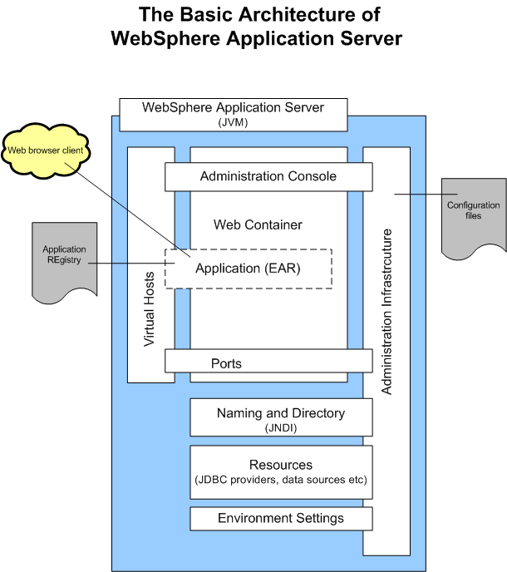

Sometimes the operator need to do some changes in the following kind of items:

|  |  |
| --- | --- |
| Resource Types | Description |
| JDBC (Java database connectivity) | Used to define providers and data sources |

And the applications that Operators Team are going to deploy, need to be of the following type:

|  |  |
| --- | --- |
| File Type | Description |
| EAR file | An Enterprise Archive file represents a J2EE application that can be deployed in a WebSphere application server. |
| WAR file | A WAR file (Web Application) is essentially a JAR file used to encapsulate a collection of JavaServer Pages (JSP), servlets, Java classes, HTML and other related files which may include XML and other file types depending on the web technology used. For information on JSP and Servlets, you can visit <http://java.sun.com/products/jsp/>. |

And to start to deploy the application you need to access to the WebSphere Administration Console, with the respective user/password of the instance in where you want to deploy the new artifact. ***(All the images contains the DefaultApplication.ear as an example)***

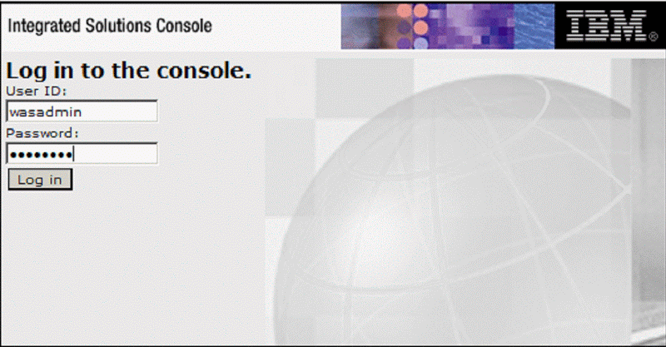

* Open the administration console and navigate to the Applications section and click on New Application as shown below.

WebSphere Application Server 7.0 Administration Guide

You now see the option to create one of the following three types of applications:

|  |  |
| --- | --- |
| Application Type | Description |
| Enterprise Application  WebSphere Application Server 7.0 Administration Guide | EAR file on a server configured to hold installable Web Applications, (WAR), Java archives, library files, and other resource files. |

* Click on **New Enterprise Application**.

The following screenshot depicts the path to the new application:

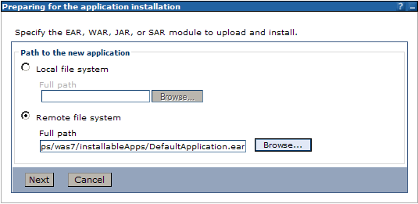

* Click **Browse....**

You will see the name of the application server node:

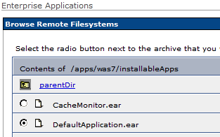

* Locate the SEL artifact that you want to deploy. Click **Next** to begin installing the artifact file.



* We will select **Fast Path** as demonstrated in the following screenshot and Click on **Next**:

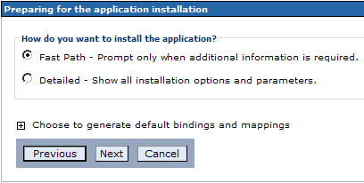

* Move on to the Map modules to server page. Accept defaults and click **Next**

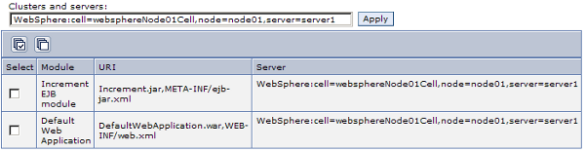

* Click **Save** to continue. The application has now been deployed.

We are going to start the SEL application

* Select **the corresponding artefact** and click on the **Start** action,

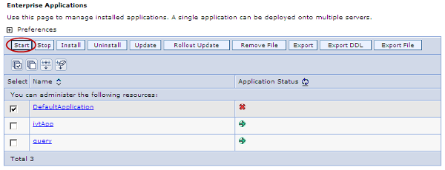

* When an application has successfully started, you will a message similar to the one shown below:

WebSphere Application Server 7.0 Administration Guide

* Now, **DefaultApplication** is started, we can use a web browser to navigate to the URL.

## SEL Servers Information

|  |  |  |  |  |
| --- | --- | --- | --- | --- |
| **Scotia en Linea (SEL) Application** | | | | |
| Aplicación empresarial - **SCOTIABANK** | | | | |
|  |  |  |  |  |
| **#** | **Server** | **Layer** | **Type** | **Environment** |
|
| 1 | mxmexudr1as0082 | Application Server | IBM AIX | DRP |
| 2 | mxmexudr1as0083 | Application Server | IBM AIX | DRP |
| 3 | mxmexudr3as0039 | Application Server | IBM AIX | DRP |
| 4 | mxmexudr3ds0069 | Database Server | IBM AIX | DRP |
| 5 | mxmexudr3ws0038 | Web Server | IBM AIX | PROD |
| 6 | mxmtyupr1as0028 | Application Server | IBM AIX | PROD |
| 7 | mxmtyupr1as0029 | Application Server | IBM AIX | PROD |
| 8 | mxmtyupr1as0030 | Application Server | IBM AIX | PROD |
| 9 | mxmtyupr1as0031 | Application Server | IBM AIX | PROD |
| 10 | mxmtyupr1as0071 | Application Server | IBM AIX | PROD |
| 11 | mxmtyupr1as0221 | Application Server | IBM AIX | PROD |
| 12 | mxmtyupr1as0222 | Application Server | IBM AIX | PROD |
| 13 | mxmtyupr1cl0033 | Cluster | IBM AIX | PROD |
| 14 | mxmtyupr1ds0032 | Database Server | IBM AIX | PROD |
| 15 | mxmtyupr1ws0026 | Web Server | IBM AIX | PROD |
| 16 | mxmtyupr1ws0027 | Web Server | IBM AIX | PROD |
| 17 | mxmtyupr1as0072 | This server was found in the topology diagram but is not in the SEL Servers List | | |
| 18 | uxselap130 | Application Server | Apoyo para definir | IST |
| 19 | uxselap230 | Web Server | Apoyo para definir | IST |
| 20 | uxseldb30 | Database Server | Apoyo para definir | IST |
| 21 | mxmexuut3ws2033 | Web Server | Apoyo para definir | UAT |
| 22 | mxmexuut3ws2034 | Web Server | Apoyo para definir | UAT |
| 23 | mxmexuut3as2029 | Application Server | Apoyo para definir | UAT |
| 24 | mxmexuut3as2030 | Application Server | Apoyo para definir | UAT |
| 25 | mxmexuut1ds2031 | Database Server | Apoyo para definir | UAT |
| 26 | mxmexuut1cl2032 | Database Server | Apoyo para definir | UAT |